Stage Review: ‘Bad Jews' at Circuit Playhouse mines religious, cultural conflict
Jon W. Sparks
4:28 PM, Jan 23, 2015
stage reviews
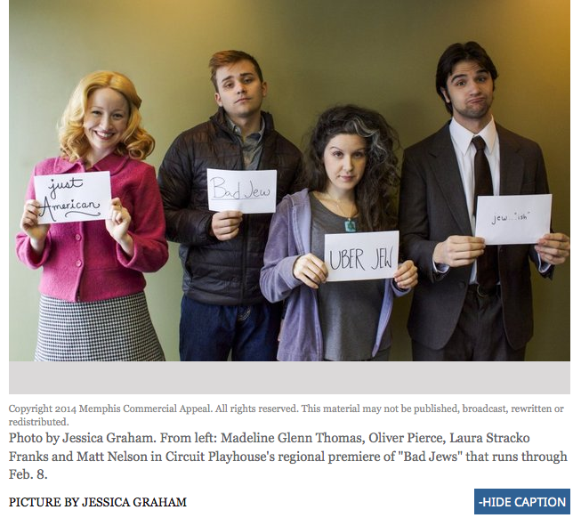
The savagely funny and heartbreaking “Bad Jews” works its agonies on so many levels.
There is a richness and variety of language, renderings of love true and false, complex feelings about religion, and, ultimately, a lesson in how the inevitability of social change can corrode traditional cultures.
The story is of three twenty-something American Jews with varying devotion to the faith and how they regard the past and the future. Daphna is fully and loudly committed to the religion and the culture. Her cousins, Liam and Jonah, are less intense — in fact, Liam is hostile to most things Jewish. They have come together after the death of their grandfather and their feelings boil over regarding the patriarch’s Chai pendant and the religious and personal things it represents. Also in the mix is Liam’s shiksha girlfriend, Melody, who tries her best to fit in with this group of squabbling cousins.
Director Anita ‘Jo’ Lenhart has forged a nonstop production where the characters are almost always on the move, rhythmically shifting and changing and trying to find a moment’s peace in a small apartment.
The four actors are splendid, sharply etching their characters as they go along. Laura Stracko Franks is a vivid Daphna — intellectual, quick-witted, sarcastic. Her monologue rants are virtuosic as she sets up her targets only to bring them down, twisting the knife long past the fatal thrust.
But cousin Liam, well played by Oliver Jacob Pierce, is a match for her, very much like her in many ways even as his religious feelings are her opposite. He is calculating, purposeful and intends to win all the time. Together, Liam and Daphna are highly combustible and — in pursuing their own agendas — make everyone else in the room entirely uncomfortable.
Matt Nelson’s nervous Jonah knows his brother and cousin and is content to stay in the shadows, except that the arguments are so explosive, there are few shadows that allow escape. Melody feels entirely out of place and Madeline Glenn Thomas does remarkable work finding the precise center of her character in a way that avoids overt caricature. Thomas also sings a song that, in its way, hits all the right notes and she nails it.
The playwright, Joshua Elias Harmon, has given us a story of an heirloom, of Jews, of youth, and with a roller coaster of dialogue and emotions. Yet the story is fully about culture, anyone’s culture anywhere in the world. It shows, with its dark humor and rapidly paced dialogue, that heritage can be held too tightly or too loosely, and that having a life of liberty and choices makes the dilemma no easier.
-----
“Bad Jews”
Through Feb. 8 at Circuit Playhouse, 51 S. Cooper St.
Showtimes: Thursdays, Fridays and Saturdays at 8 p.m., Sundays at 2 p.m.
Tickets: $30 Thursdays and Sundays, $35 Fridays and Saturdays. $22 Seniors/Students/Military. $10 Children under 18.
For info: 901-726-4656 and playhouseonthesquare.org. The show has strong language and content.
http://www.commercialappeal.com/go-memphis/arts/stage-reviews/stage-review-bad-jews-at-circuit-playhouse_62394615

