Thursday, January 29, 2015

"Bad Jews" is Good Theater at Circuit Playhouse

Posted By Chris Davis on Thu, Jan 29, 2015 at 12:01 PM

The Memphis Flyer

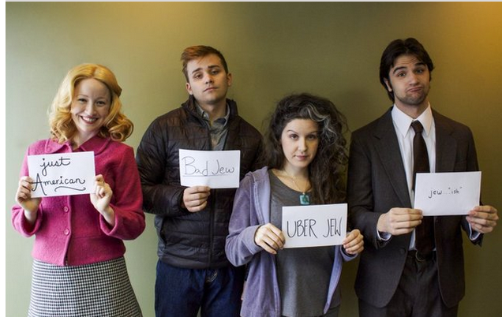Good theater isn't always pleasant. Remind yourself of this caution as the lights dim and you prepare for the onslaught of Bad Jews.
Bad Jews has one of the best end reveals I’ve ever seen. It’s not shocking or especially surprising. And it doesn’t really change how audiences see the characters, though it certainly changes how some of the characters regard themselves. It’s a touching moment that picks up lost threads of throwaway conversation from earlier in the scrip, to make unexpected, perfectly poetic, and entirely wordless comments about tradition, trend, and the meaning of meaning. This isn’t a play about how ritual dissipates, but how it evolves. Joshua Elias Harmon’s difficult show also highlights a universal truth: Still waters run deepest.
The only problem with this closing image, as I see it, is that you have to spend an hour and forty (funny, finely acted) minutes with some extremely unpleasant characters to get there.
Bad Jews is a deliberately provocative title. It invites people to judge before peeling back the layers to see what’s really there. Another, more prominent critic, suggested “Jews Behaving Badly” might make for a better title, though, for all of its accuracy, I find that a little “on the nose,” without the benefit of offering less potential for offense. This is a show about personal and cultural narcissism: people with strong feelings and weak connections, that judge one another using their own reflections as a gold standard. Conservatives dismiss progressives who sneer at the conservatives in the great circle of modern life. Watching the characters go at it is a little bit like reading an argument on the internet, and even though it can be very funny, it requires more than a little patience.
The shell story couldn’t be more simple. The family patriarch has passed, and the college age cousins gather for the funeral. The oldest male arrives late because he was off on a skiing holiday with his shiksa girlfriend, and lost his phone in the snow. The conflict—often hateful and cringe inducing— is built around which cousin will inherit a gold chai amulet their grandfather kept under his tongue in a Nazi concentration camp. Daphna, who is leaving America to marry an Israeli soldier and join the military herself, thinks she deserves the chai because of some perceived spiritual significance. Cousin Liam, who prefers Christmas trees and Santa hats, thinks it should be his simply because he’s next in the line of succession.
Director Anita Jo Lenhart, who did such a bang up job with last season’s As You Like It at Theatre Memphis, had her work cut out for her. Thankfully, she scored a top shelf cast, lead by the remarkable Laura Stracko Franks, who knows how to work Bad Jews' limited dynamics, and never allows the show to become a one note shrill-fest. That's 90% of the battle.
As Daphna, Frank owns the space, stomping around with an unruly mane of hair that makes her seem twice her actual size. Liam, nicely played by Oliver Jacob Pierce, mocks her openly with no idea that he’s just like her.
The show’s less showy, but more interesting roles go to Madeline Glenn Thomas , who plays a WASPY opera major who can’t sing a note, and Matt Nelson as Jonah, who may be the one person in the family with some real sense of who he is and what he believes.
I love synchronicity. And love that Bad Jews is playing just across the street from Katori Hall’s moody Hoodoo Love.
Hall’s script has its origins in a college playwriting assignment where the young dramatist was asked to develop a scene showing two characters struggling for possession of an object. Hall made her characters fight for a mojo bag— a pouch full of associative magic. And Hall, like all great writers, knows that these kinds of struggles are almost never about the thing itself, but about power, perception, and meaning. To that end, Bad Jews functions as an unexpected reflection of Hoodoo Love, which still contains a remnant of that original scene. It’s very nifty to see these two very different plays built around similarly associative artifacts and the people who have given the objects their meaning and power. See both, and you’ll see what I mean.

