Stage Review: ‘Bad Jews' at Circuit Playhouse mines religious, cultural conflict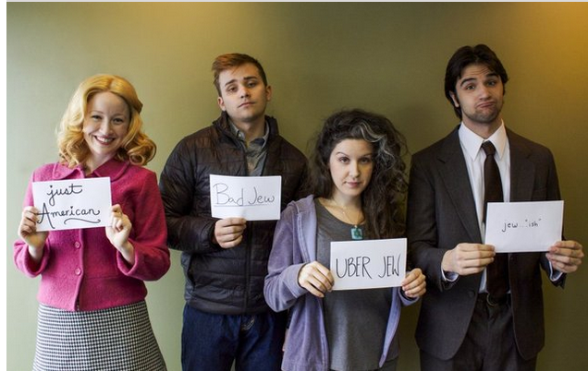
Jon W. Sparks
4:28 PM, Jan 23, 2015
The Commercial Appeal
Memphis
The savagely funny and heartbreaking “Bad Jews” works its agonies on so many levels.
There is a richness and variety of language, renderings of love true and false, complex feelings about religion, and, ultimately, a lesson in how the inevitability of social change can corrode traditional cultures.
The story is of three twenty-something American Jews with varying devotion to the faith and how they regard the past and the future. Daphna is fully and loudly committed to the religion and the culture. Her cousins, Liam and Jonah, are less intense — in fact, Liam is hostile to most things Jewish. They have come together after the death of their grandfather and their feelings boil over regarding the patriarch’s Chai pendant and the religious and personal things it represents. Also in the mix is Liam’s shiksha girlfriend, Melody, who tries her best to fit in with this group of squabbling cousins.
Director Anita ‘Jo’ Lenhart has forged a nonstop production where the characters are almost always on the move, rhythmically shifting and changing and trying to find a moment’s peace in a small apartment.
The four actors are splendid, sharply etching their characters as they go along. Laura Stracko Franks is a vivid Daphna — intellectual, quick-witted, sarcastic. Her monologue rants are virtuosic as she sets up her targets only to bring them down, twisting the knife long past the fatal thrust.
But cousin Liam, well played by Oliver Jacob Pierce, is a match for her, very much like her in many ways even as his religious feelings are her opposite. He is calculating, purposeful and intends to win all the time. Together, Liam and Daphna are highly combustible and — in pursuing their own agendas — make everyone else in the room entirely uncomfortable.
Matt Nelson’s nervous Jonah knows his brother and cousin and is content to stay in the shadows, except that the arguments are so explosive, there are few shadows that allow escape. Melody feels entirely out of place and Madeline Glenn Thomas does remarkable work finding the precise center of her character in a way that avoids overt caricature. Thomas also sings a song that, in its way, hits all the right notes and she nails it.
The playwright, Joshua Elias Harmon, has given us a story of an heirloom, of Jews, of youth, and with a roller coaster of dialogue and emotions. Yet the story is fully about culture, anyone’s culture anywhere in the world. It shows, with its dark humor and rapidly paced dialogue, that heritage can be held too tightly or too loosely, and that having a life of liberty and choices makes the dilemma no easier.
-----
“Bad Jews”
Through Feb. 8 at Circuit Playhouse, 51 S. Cooper St.
Showtimes: Thursdays, Fridays and Saturdays at 8 p.m., Sundays at 2 p.m.
Tickets: $30 Thursdays and Sundays, $35 Fridays and Saturdays. $22 Seniors/Students/Military. $10 Children under 18.
For info: 901-726-4656 and playhouseonthesquare.org. The show has strong language and content.

‘Bad Jews' promises to push buttons in regional premiere at Circuit Playhouse
Jon W. Sparks
8:00 AM, Jan 14, 2015
The Commercial Appeal
Memphis
From the moment the title smacks you in the face, you know “Bad Jews” promises to shake things up.
Joshua Harmon’s acclaimed dark comedy, a 2012 Off-Broadway hit, has recently become one of the most produced plays around the country. It’s having a regional premiere this weekend at Circuit Playhouse, and if it’s received as it has been elsewhere, it promises to push plenty of buttons.
The story brings together two cousins after the death of their grandfather, a Holocaust survivor. Daphna is most devout, and she’s planning to go to Israel with her Israeli boyfriend. She wants her grandfather’s chai pendant for its deep personal and religious meaning. Cousin Liam — the secular one — has brought his shiksa girlfriend, Melody, and also has his eye on the heirloom. Thus begins a war of words that is less about the object and more about culture.
Says director Anita “Jo” Lenhart: “A lot of people say the story is about fighting over an heirloom, but the real question is who carries this culture forward in the way it should be — who are we now?”
She says it’s distinctly Jewish, bringing up very specific aspects of Jewish culture, but it has a universal flavor.
“It brings up questions that every third or fourth generation of 20-somethings confront in every culture,” Lenhart says. “As I watch it and read it and work on it, I think about my culture. I’m third generation out of a sharecropper culture and think about losing those values and music and that way of life.”
The universal dynamic of the situation is expressed in a poem that’s quoted in the play. “One of the lines in the poem is, ‘When it’s gone, it’s gone,’” she says. “Daphna echoes that when she asks her cousin, ‘Do you want to stop being Jewish, and do you want me to stop? Because you know if I stop, when it’s gone, it’s gone.’”
Lenhart says that when Playhouse on the Square founder and executive producer Jackie Nichols invited her to direct, she was stunned to hear the title. “I don’t know if it was because I was raised Catholic,” she says, “but my first thought, a very silly thought, was, ‘There are no bad Jews!’ But I needed to read the play, and when I did, I was struck with what Harmon has created here, the way the language flows.”
She says the playwright knows dramatic language well and how to manipulate it. “He reflects the current state of the language among young people,” she says. “It says something about disintegration — they’re trying to navigate through words to find out how to express their feelings about this crisis in culture. They begin in some ways with very fragmented arguments. Then they swing into articulate and intractable diatribes on the issues at hand. So the language itself is like going on a roller coaster ride.”
Lenhart, an associate professor in the Theatre and Dance Department at the University of Memphis, won a Best Director Ostrander Award for “King Lear” at New Moon Theatre in 2012, and last year she helmed a smartly conceived, well played and critically lauded version of “As You Like It” on the Next Stage of Theatre Memphis.
She says she and the quartet of actors have more of a collaborative relationship. “They’re thoughtful, sensitive and intelligent actors,” she says. “This could never be me coming in and dictating anything because they bring these three-dimensional folks to life. I hope that as audience members are about to make up their minds to not like somebody, the cast won’t let them do that. The audience will not be off the hook trying to decide who’s right.”
'Bad Jews'
Through Feb. 8 at Circuit Playhouse, 51 S. Cooper.
Showtimes: 8 p.m. Thursdays, Fridays and Saturdays, 2 p.m. Sundays.
Tickets: $22 opening weekend (tonight-Sunday), $30 Thursdays and Sundays, $35 Fridays and Saturdays; $22 seniors/students/military; $10 children under 18.
For info: 901-726-4656 and playhouseonthesquare.org. Show has strong language and content

